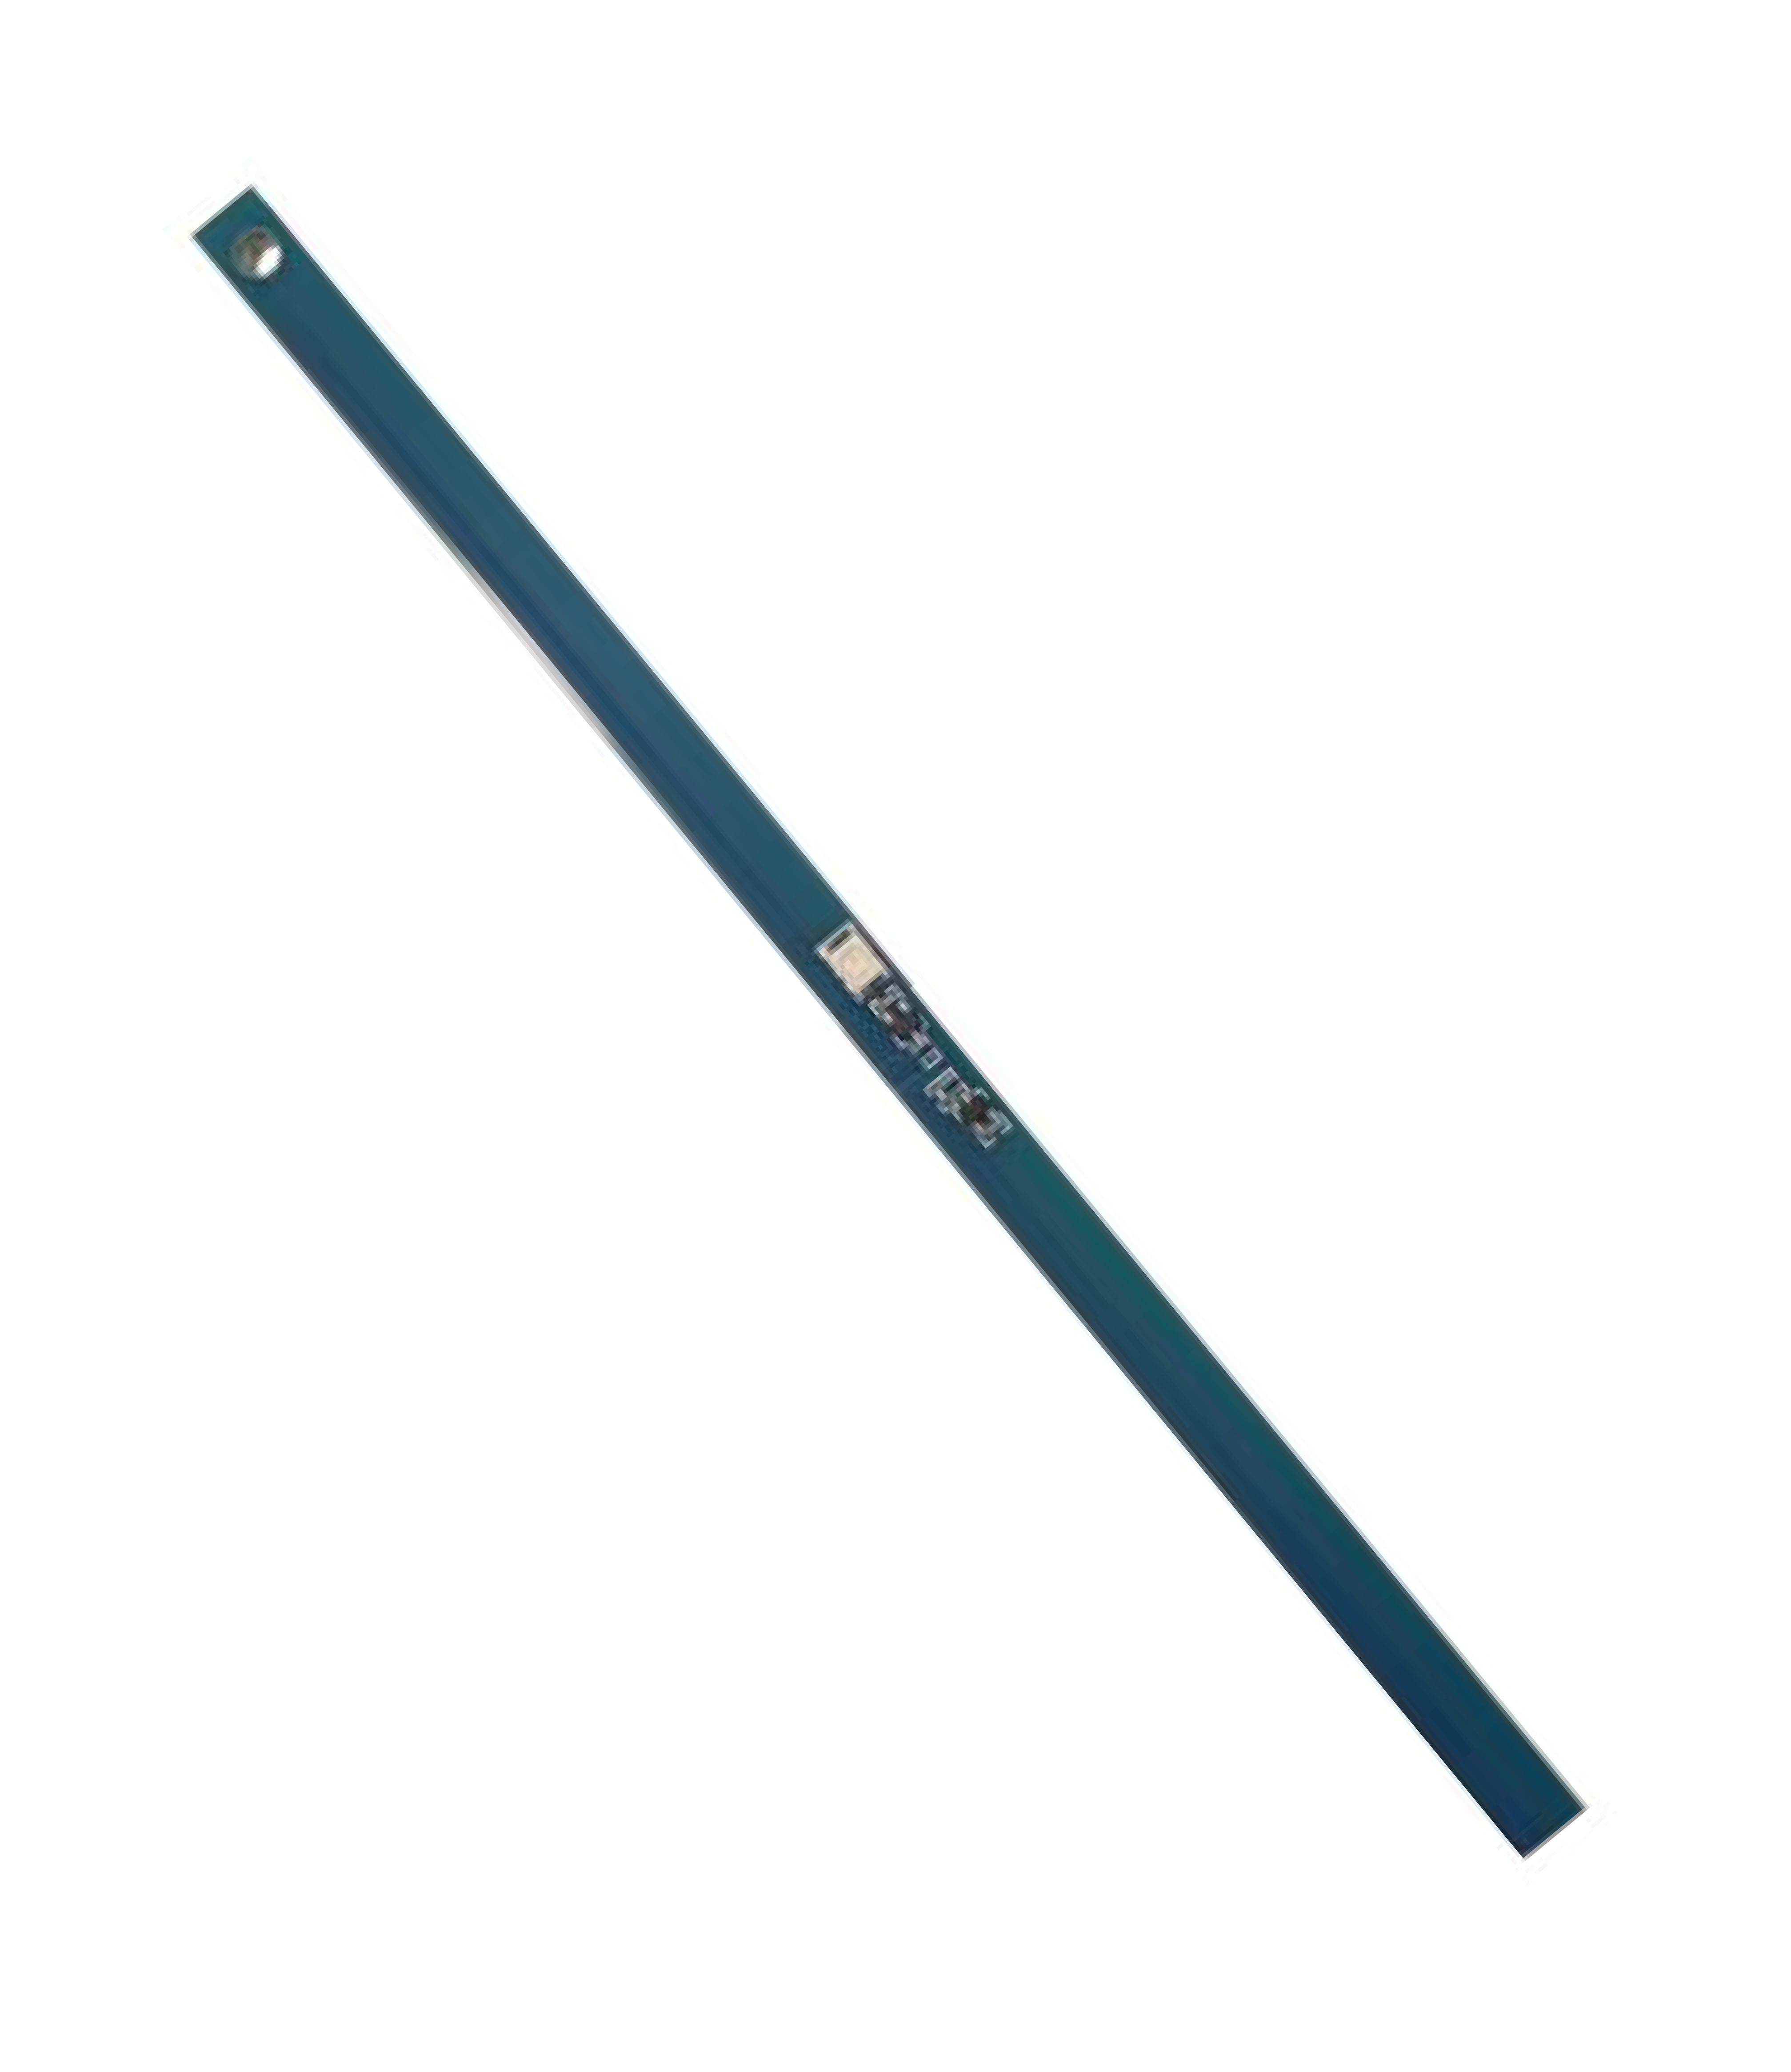

**APPLICATIONS**

* RF Field Visualization
* RFID Testing and Installation
* Polarization Verification

**MOUNTING INSTRUCTIONS**

Mount the RF Field Detector using the hole located at the top. When holding, hold from the end with the hole as close to the edge of the board as possible. Function may be drastically reduced when mounted on a metal surface

**DIMENSIONS**



**DESCRIPTION**

The PS915 RF Field Detector enables simple RF field detection in the 902-928 MHz ISM band. The PS915 comes with two different color options, red or green and works with the Powercast TX91501 transmitter or any UHF RFID reader.

**FUNCTION**

The PS915 functions by utilizing Powercast’s Powerharvester technology to efficiently convert the RF energy into DC power. This converted DC power is then supplied to the onboard LED. The more RF energy harvested, the brighter the LED will be.

**ELECTRICAL CHARACTERISTICS**

|  |  |
| --- | --- |
| Frequency | 850-950MHz (915 Typ.) |
| Antenna Type | Dipole |
| Polarization | Vertical |
| Antenna Pattern | Omni-directional |
| Operating Temperature | -40 to 85°C |

**ORDERING INFORMATION**

The PS915 is available in two different colors; red and green.

***Powercast products and technology are covered by one or more patents with other patents pending. All patent and trademark information can be found at*** [***http://www.powercastco.com/IP/***](http://www.powercastco.com/IP/)***.***

**Powercast Corporation**

620 Alpha Drive

Pittsburgh, PA, USA 15238

[www.powercastco.com](http://www.powercastco.com)

[contact@powercastco.com](mailto:contact@powercastco.com)

+1 (412)-455-5800

**CRITICAL APPLICATIONS DISCLAIMER**

POWERCAST PRODUCTS (INCLUDING HARDWARE AND/OR SOFTWARE) ARE NOT DESIGNED OR INTENDED TO BE FAIL-SAFE, FAULT TOLERANT OR FOR USE IN ANY APPLICATION THAT COULD LEAD TO DEATH, PERSONAL INJURY OR SEVERE PROPERTY OR ENVIRONMENTAL DAMAGE (INDIVIDUALLY AND COLLECTIVELY, “CRITICAL APPLICATIONS”), SUCH AS LIFE-SUPPORT OR SAFETY DEVICES OR SYSTEMS, CLASS III MEDICAL DEVICES, NUCLEAR FACILITIES, APPLICATIONS THAT AFFECT CONTROL OF A VEHICLE OR AIRCRAFT, APPLICATIONS RELATED TO THE DEPLOYMENT OF AIRBAGS, OR ANY OTHER CRITICAL APPLICATIONS. CUSTOMER AGREES, PRIOR TO USING OR DISTRIBUTING ANY SYSTEMS THAT INCORPORATE POWERCAST PRODUCTS, TO THOROUGHLY TEST THE SAME FOR SAFETY PURPOSES. CUSTOMER ASSUMES THE SOLE RISK AND LIABILITY OF ANY USE OF POWERCAST PRODUCTS IN CRITICAL APPLICATIONS, SUBJECT ONLY TO APPLICABLE LAWS AND REGULATIONS GOVERNING LIMITATIONS ON PRODUCT LIABILITY.

Powercast warrants its products in accordance with Powercast’s standard warranty available at [www.powercastco.com/terms-conditions](http://www.powercastco.com/terms-conditions)

## IMPORTANT NOTICES

Information furnished by Powercast Corporation (Powercast) is believed to be accurate and reliable. However, no responsibility is assumed by Powercast for its use, nor for any infringements of patents or other rights of third parties that may result from its use.

Specifications are subject to change without notice.

No license is granted by implication or otherwise under any patent or patent rights of Powercast. Trademarks and registered trademarks are the property of their respective owners.